NEW A134 Dis-Eur-Germany-Hohe Fels Cave-Waterfowl Figurine

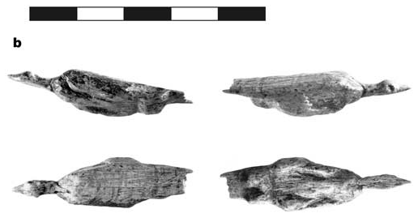

**Fig. 1. Hohe Fels Cave Upper Paleolithic Waterfowl Figurine** that may be the earliest representation of a bird in the archaeological record C14 dated between 33,000 and 30,000 BP. The scale bar is 5 cm (Conard 2003).

**Formal Label: Germany, Hohe Fels Cave Upper Paleolithic Waterfowl Figurine**

**Accession Number: A 134**

**LC Classification:** GN772.22.G4

**Date or Time Horizon:** 33,000-30,000 BP

**Geographical Area:** Schwaben Jura, Germany

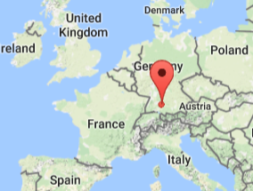 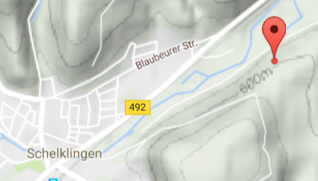

**Fig. 2. Map: Hohe Fels Cave Location. From https://www.google.com/maps/place//@47.6151055,-1.6433072.**

**Cultural Affiliation:** **Upper Paleolithic**

**Medium: Mammoth Ivory**

**Dimensions: original** L 47; W 13; D 9. **Weight:**

**Provenance:** recovered fromarchaeological horizon IV

**Condition: Museum Reproduction in Resin**

**Discussion:** recovered fromArchaeological Horizon IV, where nine radiocarbon dates measured in Kiel and Oxford on bone fall between 33,000 and 30,000 BP. “The body of the Figurine 2 was recovered in 2001 from AH IV near the bottom of the Aurignacian sequence. In 2002 the head and neck of the figurine were recovered from AH IV and confirm that the sculpture depicts a water bird with a morphology similar to that of a diver, cormorant or duck. This figurine has dimensions of 47 x 13 x 9 mm. The extended neck of the bird is strongly suggestive of a waterfowl in flight or diving. The wings are depicted close to the body. As compared with many finely carved figurines of the Swabian Aurignacian, the front of the bird has been left in a seemingly unfinished state. The other parts of the bird are presented in greater detail. Both eyes are easily recognizable, and the beak has a conical, pointy form that one would not expect on many of the common ducks. The legs of the bird are short with no indications of feet. The tail of the figurine extends below the legs and is depicted as a finely carved flat splint. The back of the bird shows a series of distinct lines that apparently represents feathers” (Conard 2003).

**References:**

.

Conard, N. J. 2003. “Palaeolithic ivory sculptures from southwestern Germany and the

origins of figurative art,” *Nature* 426: 830–832.